# Project Title: Automated Solar Tracker System

## Team Members:

* Rohit Jangra – Research and Development
* Aman Gupta- Project Manager
* Kunal Mittal- Electronics manager
* Akshita Dangi- Hardware Designer
* Pranathi – Design and craft

---

## Introduction:

**With the rapid depletion of conventional energy sources, the world is increasingly turning to renewable energy, with solar power being a major contributor. However, a vast majority of solar installations are fixed, limiting their efficiency. Maximizing energy output is critical, and an automated solar tracker system presents a significant opportunity to enhance energy collection from the same infrastructure.**

## Problem Statement:

**Fixed solar panels are suboptimal in capturing sunlight, producing only about *20-25%* of their potential energy due to the sun's changing position throughout the day. The need for greater efficiency is evident, as demand for renewable energy is surging.**

## Facts and Figures:

* **Fixed solar panels typically convert *15-18%* of the sun's energy into electricity.**
* **An automated solar tracker can increase energy production by *25-30%* due to its ability to follow the sun's movement, maintaining the optimal angle for energy capture.**
* **According to global studies, a single automated solar tracker can generate up to *40%* more energy annually compared to its fixed counterpart.**

## Solution:

**Our proposed Automated Solar Tracker System addresses this problem by utilizing sensors and motors to adjust the solar panels' orientation throughout the day. This simple yet effective mechanism ensures panels are always optimally positioned to capture the maximum sunlight.**

## Example of an Indian Household

**Location: Jaipur, Rajasthan  
Household Size: 4 members  
Average Monthly Electricity Consumption: 300 units (kWh)  
Electricity Cost: ₹8 per unit (kWh)  
Current Electricity Bill: ₹2400 per month**

**This household is interested in installing a solar power system to reduce its electricity bills.**

**Comparison: Fixed Solar Panel System vs. Automated Solar Tracker System**

| **Parameter** | **Fixed Solar Panel System** | **Automated Solar Tracker System** |
| --- | --- | --- |
| **System Type** | **Fixed rooftop solar panels** | **Automated solar panels with dual-axis tracking** |
| **Initial Cost** | **₹60,000 - ₹80,000 (1 kW system)** | **₹1,20,000 - ₹1,40,000 (1 kW system)** |
| **Power Generation Efficiency** | **15% - 20%** | **30% - 40% higher than fixed panels** |
| **Daily Energy Output (1 kW)** | **4-5 kWh (in Jaipur, average)** | **6-7 kWh (30-40% more energy due to tracking)** |
| **Monthly Energy Output (1 kW)** | **120-150 kWh (fixed)** | **180-210 kWh (with tracker)** |
| **Payback Period** | **5-6 years** | **6-8 years** |
| **Impact of Shading** | **High (fixed panels are affected by shading)** | **Low (trackers can adjust to maximize sunlight)** |
| **Energy Savings** | **₹12,000 - ₹15,000 per year** | **₹18,000 - ₹21,000 per year** |

**Explanation of Differences**

1. **Initial Cost:**
   * **Fixed Solar Panels: Cheaper to install with a lower initial investment (₹60,000 - ₹80,000 for a 1 kW system).**
   * **Automated Solar Tracker: Higher initial cost (₹1,20,000 - ₹1,40,000 for a 1 kW system) due to the tracking mechanism.**
2. **Power Generation Efficiency:**
   * **Fixed Panels: Typically achieve 15-20% efficiency.**
   * **Automated Tracker: Can increase efficiency by 30-40% by continuously adjusting the panel angle to follow the sun’s path, thus capturing more sunlight throughout the day.**
3. **Energy Output:**
   * **Fixed Panels: Generate approximately 120-150 kWh per month per kW installed.**
   * **Automated Tracker: Produces around 180-210 kWh per month per kW due to optimal solar positioning.**
4. **Payback Period:**
   * **Fixed Panels: The lower cost results in a shorter payback period (5-6 years).**
   * **Automated Tracker: The higher cost extends the payback period to around 6-8 years, but it generates more savings over time due to higher output.**
5. **Impact of Shading:**
   * **Fixed Panels: Performance drops significantly if shading occurs.**
   * **Automated Tracker: Can adjust to minimize the impact of shading by altering the angle.**
6. **Energy Savings:**
   * **Fixed Panels: Save around ₹12,000 - ₹15,000 annually based on Jaipur's sunlight hours.**
   * **Automated Tracker: Save approximately ₹18,000 - ₹21,000 annually due to higher energy production.**

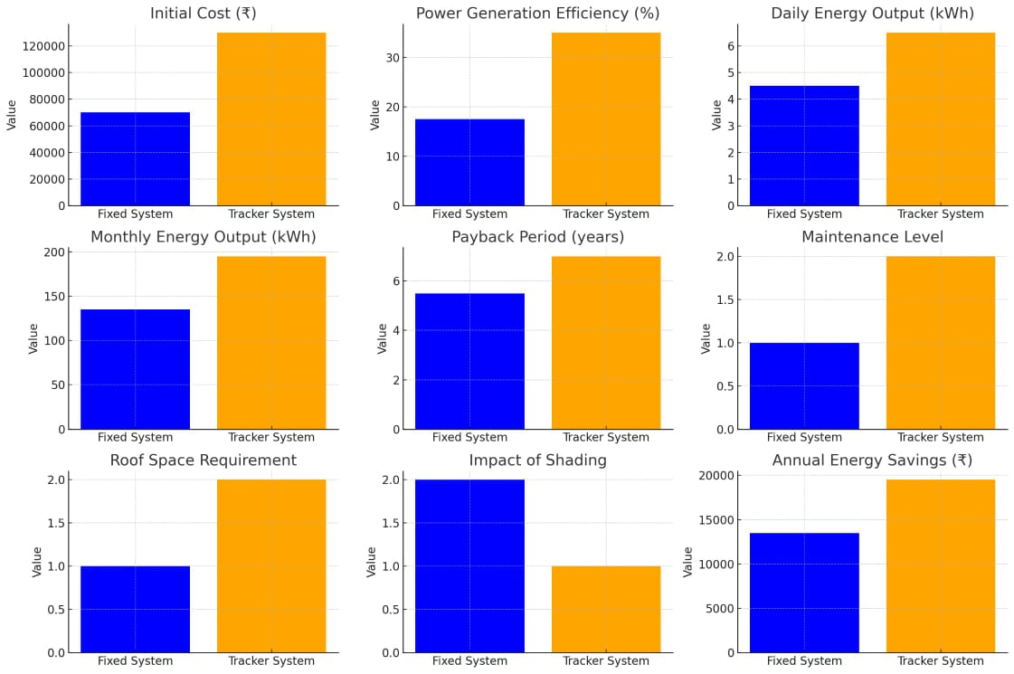

**Although automated solar tracker requires more space and initial cost of setup ,it has huge benefits which can’t be neglected.**

## Results and Benefits:

* **Increased Energy Production: The automated system enhances energy output by up to *30%*, making it a significant improvement over fixed installations.**
* **Cost-Efficient: The initial investment in automation is quickly offset by the increased energy generation and long-term savings in energy production.**
* **Reduced Effort: After installation, the tracker requires minimal maintenance, making it a low-effort solution with substantial long-term benefits.**
* **Sustainable Impact: By maximizing the efficiency of solar panels, we can reduce the land required for solar farms and further decrease dependency on non-renewable energy sources.**

## Conclusion:

**The automated solar tracker offers a small yet impactful solution to the large and pressing issue of energy inefficiency in solar power systems. By implementing this system, we can significantly boost energy production with minimal additional effort, creating a substantial and lasting positive impact on renewable energy initiatives worldwide.**